**Explain Pandas for Data Processing**

Pandas is a popular open-source Python library for data manipulation and analysis. It provides data structures for efficiently storing and manipulating large datasets, as well as tools for reading and writing data in various formats.

Here we used some sample data i.e., a dictionary which has keys and values. By using the pandas dataframe we can use the module to convert this data into table.

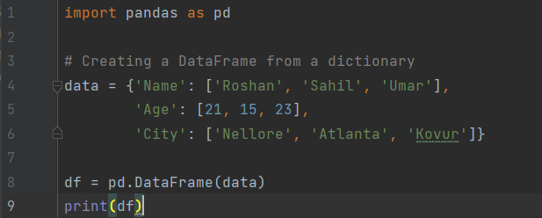

**Output:**

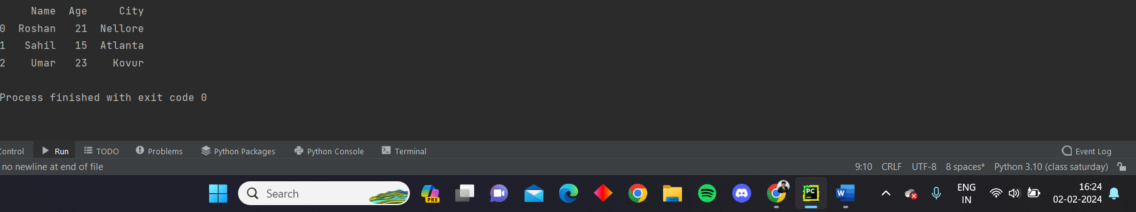

**You can see that the data is processed into a table like wise we can also perform different data cleaning and transforming operations using pandas.**

**Reading csv data using pandas:**

Initially we imported pandas as pd. To read the csv data using pandas we have a function called read_csv, here we used that function to read the data from the csv file and store it in a variable called df.

Then the contents in the variable can be printed by using the head() function. Head function reads the data line by line by eliminating the errors that can occur during the reading of data.

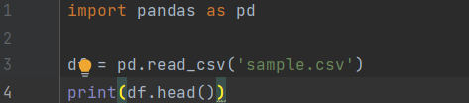

**Csv file used:**



**Output:**

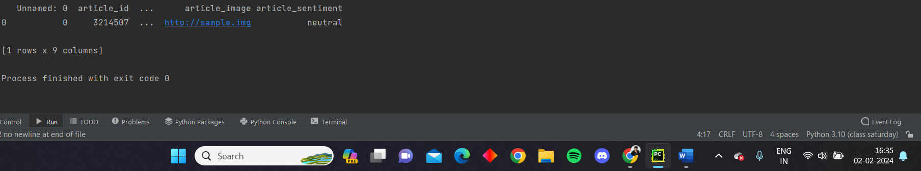

**Reading data from csv files to data frame using pandas:**

Initially we imported pandas as pd. To read the csv data using pandas we have a function called read_csv, here we used that function to read the data from the csv file and store it in a variable called df. Then the data in this df is converted into a data frame using the DataFrame function from pandas. Now as it is converted into a dataframe we can directly read the data from it. So we directly printed the data without using head function.

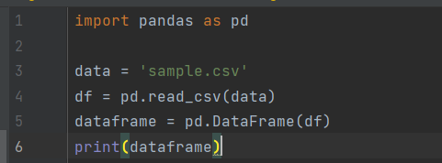

**Csv file used:**



**Output:**

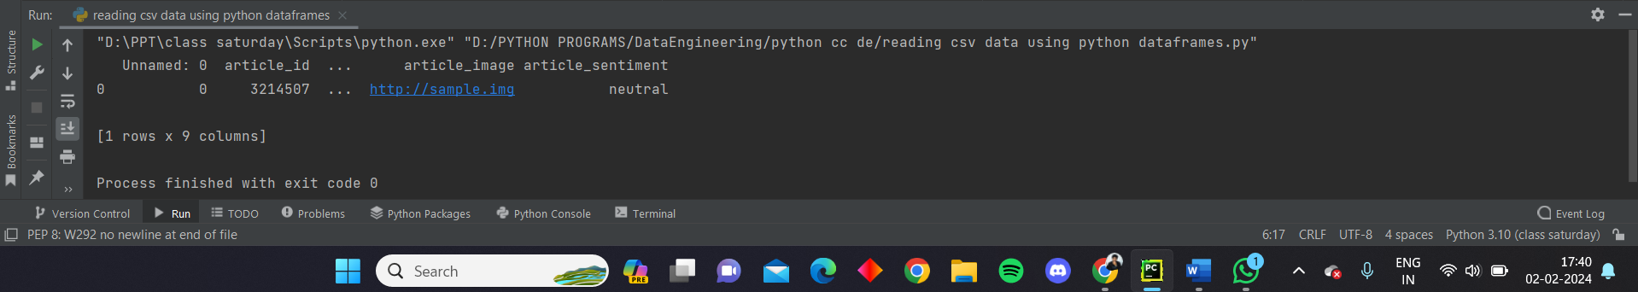

**Filter data in pandas dataframe using query:**

Initially, we import the pandas module as pd. The we create a dictionary called ‘data’ which has some sample information. This can be converted into a table by converting the data into a dataframe using the DataFrame function. Then to filter the data we use query function.

This query function takes the condition as input, which is ‘age > 20’ in the code. It only chooses the records that satisfy the condition and assigns the value to a variable called filtered_df.

Then both the previous unfiltered data and then the filtered data is printed below.

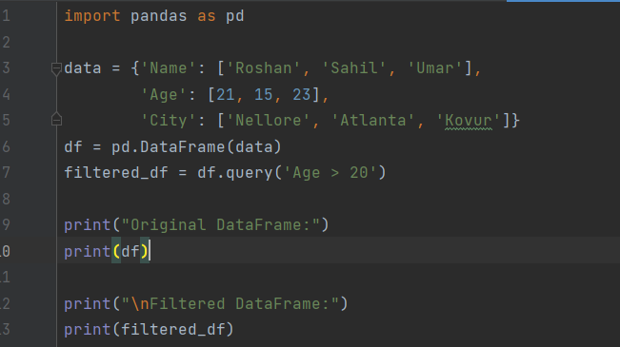

**Output:**

